**Management**

**Definition**: Management can be defined as the **process of administering and controlling the affairs of the**Organisation, irrespective of its nature, type, structure and size. It is an act of creating and maintaining such a business Environment wherein the members of the organization can work together, and achieve business objectives efficiently and effectively.

Management acts as a guide to a group of people working in the organization and coordinating their efforts, towards the attainment of the common objective.

In other words, it is concerned with **optimally using 5M’s, i.e. men, machine, material, money and methods** and, this is possible only when there proper direction, coordination and integration of the processes and activities, to achieve the desired results.

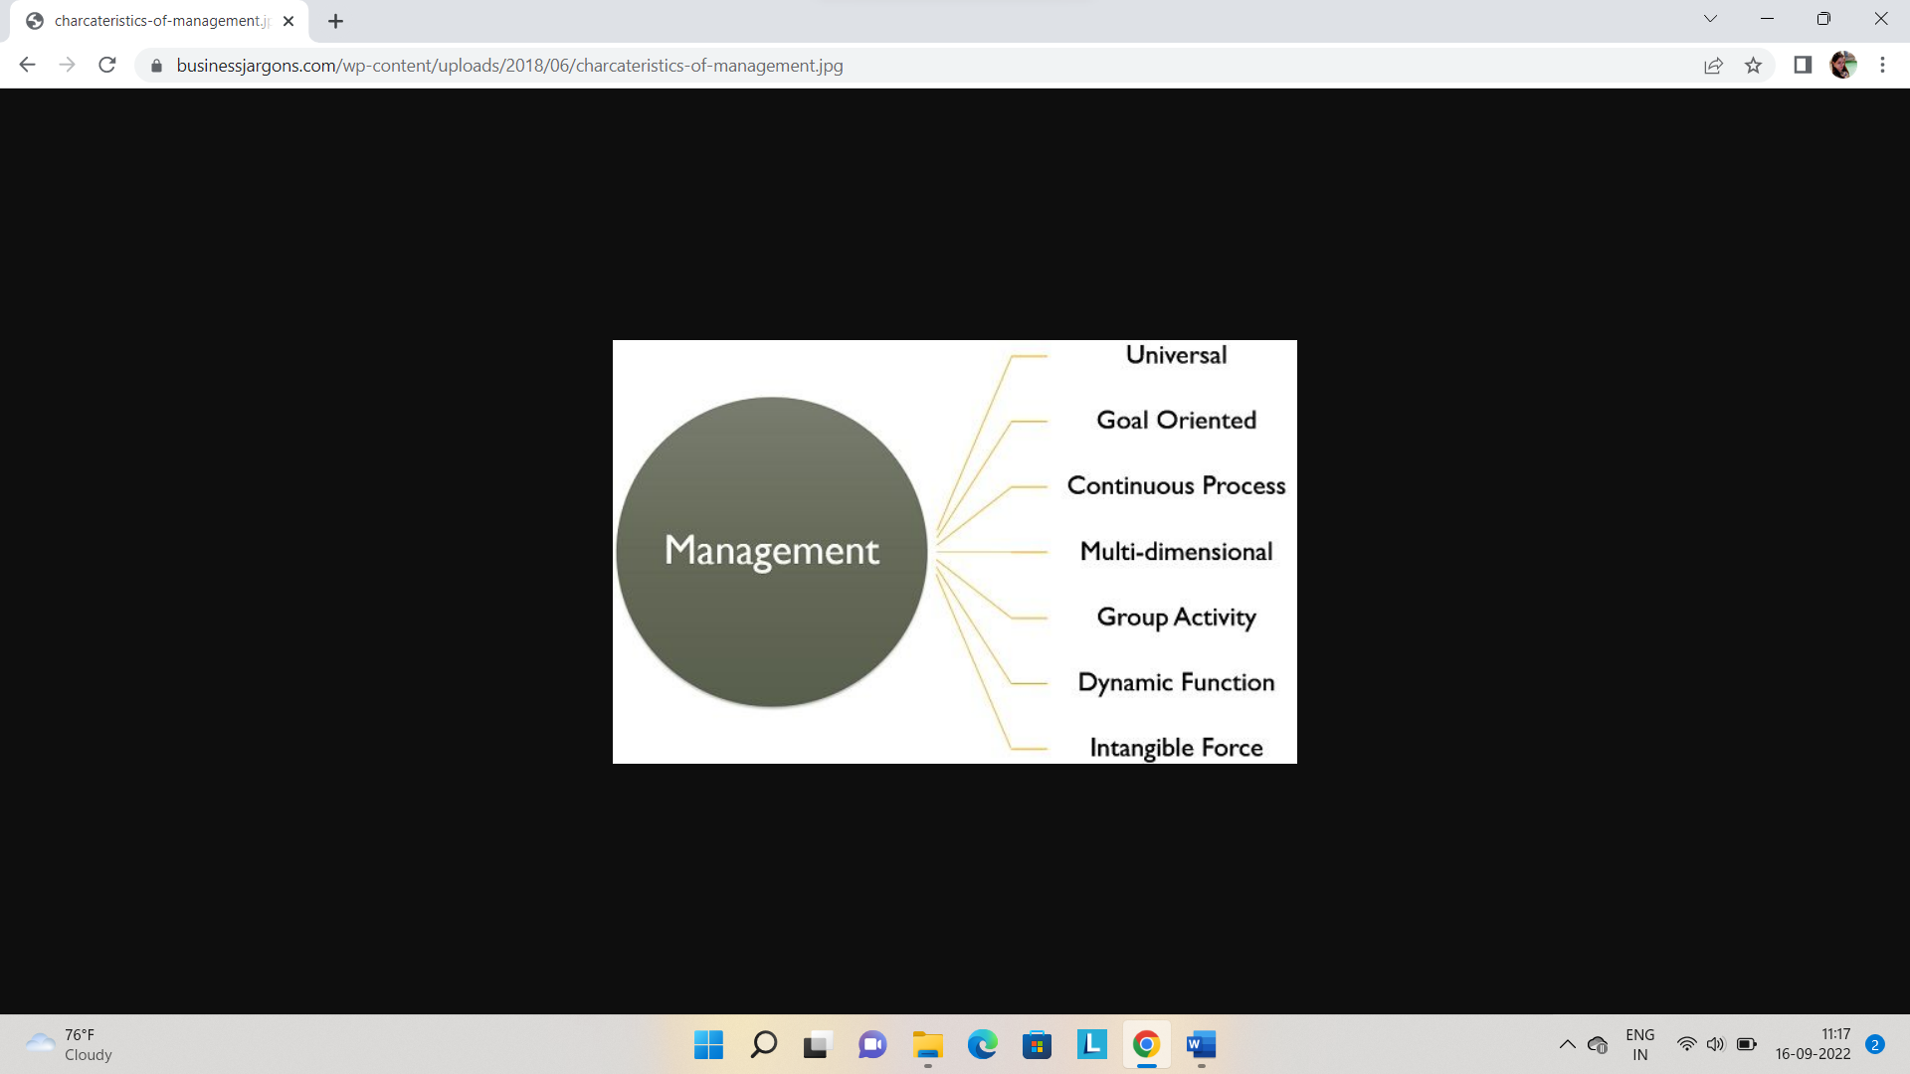

* **Universal**: All the organizations, whether it is profit-making or not, they require management, for managing their activities. Hence it is universal in nature.
* **Goal-Oriented**: Every organization is set up with a predetermined objective and management helps in reaching those goals timely, and smoothly.
* **Continuous Process**: It is an ongoing process which tends to persist as long as the organization exists. It is required in every sphere of the organization whether it is production, human resource, finance or marketing.
* **Multi-dimensional**: Management is not confined to the administration of people only, but it also manages work, processes and operations, which makes it a multi-disciplinary activity.
* **Group activity**: An organization consists of various members who have different needs, expectations and beliefs. Every person joins the organization with a different motive, but after becoming a part of the organization they work for achieving the same goal. It requires supervision, teamwork and coordination, and in this way, management comes into the picture.
* **Dynamic function**: An organization exists in a business environment that has various factors like social, political, legal, technological and economic. A slight change in any of these factors will affect the organization’s growth and performance. So, to overcome these changes management formulates strategies and implements them.
* **Intangible force**: Management can neither be seen nor touched but one can feel its existence, in the way the organization functions.

Precisely, all the functions, activities and processes of the organization are interconnected to one another. And it is the task of the management to bring them together in such a way that they help in reaching the intended result.

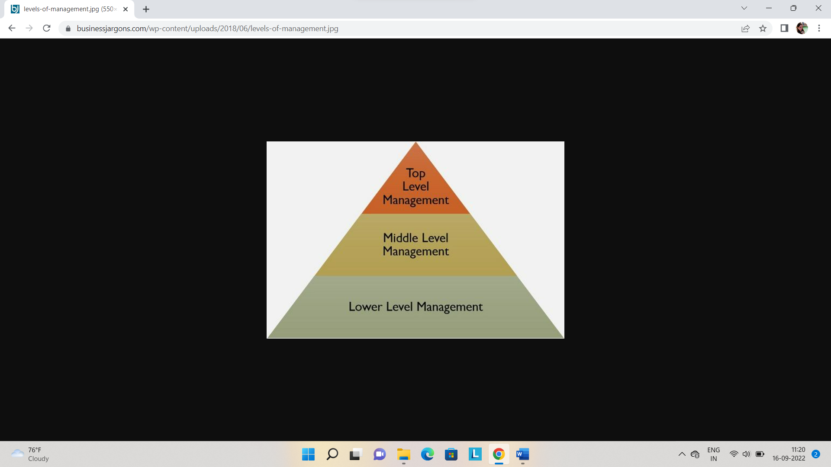

1. **op-Level Management**: This is the highest level in the organizational hierarchy, which includes **Board of Directors and Chief Executives**. They are responsible for defining the objectives, formulating plans, strategies and policies.
2. **Middle-Level Management**: It is the second and most important level in the corporate ladder, as it creates a link between the top and lower-level management. It includes **departmental and division heads and managers** who are responsible for implementing and controlling plans and strategies which are formulated by the top executives.
3. **Lower Level Management**: Otherwise called as functional or operational level management. It includes **first-line managers, foreman, supervisors**. As lower-level management directly interacts with the workers, it plays a crucial role in the organization because it helps in reducing wastage and idle time of the workers, improving the quality and quantity of output.

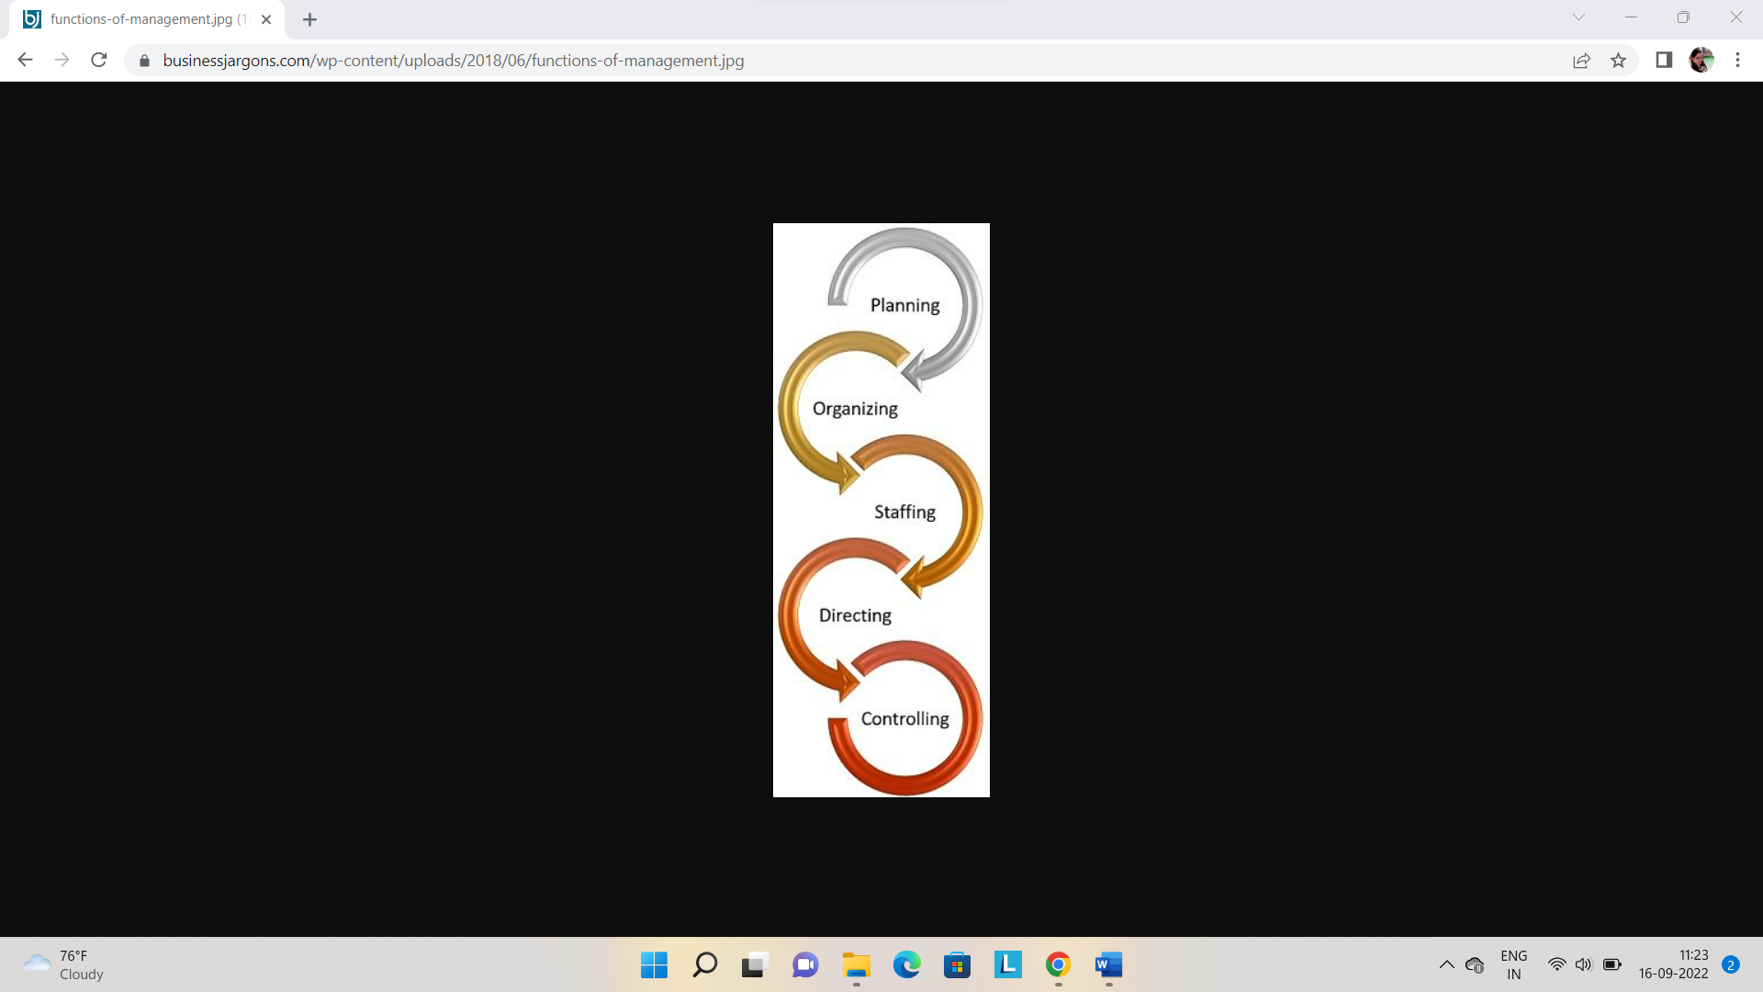

* [**Planning**](https://businessjargons.com/planning.html): It is the first and foremost function of management, i.e. to decide beforehand what is to be done in future. It encompasses formulating policies, establishing targets, scheduling actions and so forth.
* [**Organizing**](https://businessjargons.com/organizing.html): Once the plans are formulated, the next step is to organise the activities and resources, as in identifying the tasks, classifying them, assigning duties to subordinates and allocating the resources.
* [**Staffing**](https://businessjargons.com/staffing.html): It involves hiring personnel for carrying out various activities of the organization. It is to ensure that the right person is appointed to the right job.
* **Directing**: It is the task of the manager to guide, supervise, lead and motivate the subordinates, to ensure that they work in the right direction, so far as the objectives of the organization are concerned.
* [**Controlling**](https://businessjargons.com/controlling.html): The controlling function of management involves a number of steps to be taken to make sure that the performance of the employees is as per the plans. It involves establishing performance standards and comparing them with the actual performance. In case of any variations, necessary steps are to be taken for its correction.

[**Coordination**](https://businessjargons.com/coordination.html) is an important feature of management which means the integration of the activities, processes and operations of the organization and synchronisation of efforts, to ensure that every element of the organization contributes to its success.

MANAGERIAL ROLES

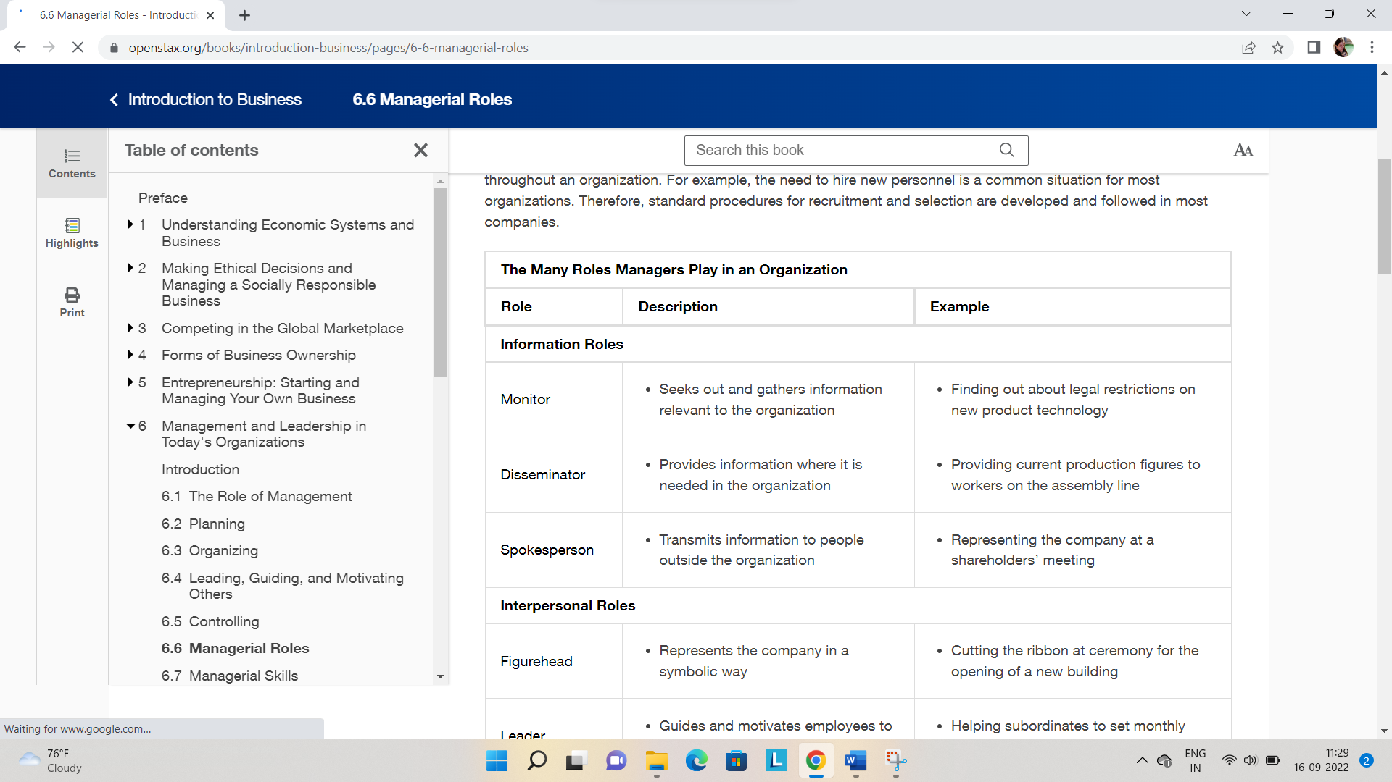

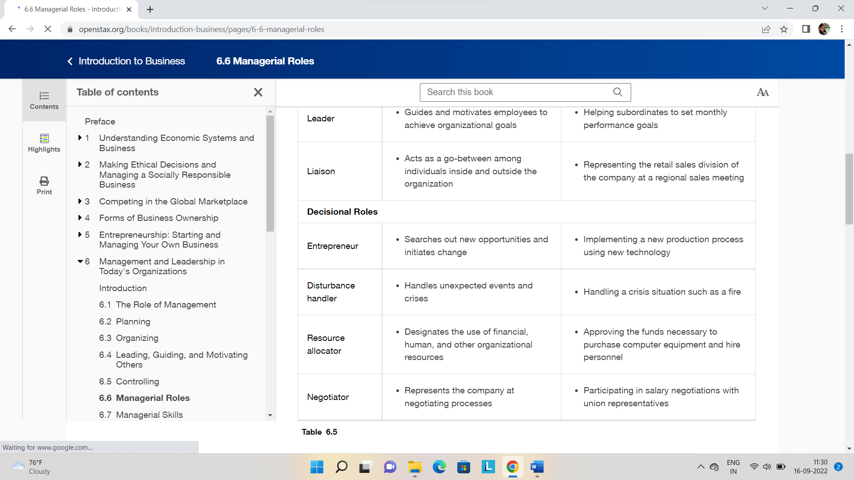

Managerial skills

1. Leadership
2. Communication
3. Collaboration
4. Critical Thinking

Managerial competencies

Managers need a myriad of interconnected general management skills to contribute to value creation for their respective organizations, however the four key skills each manager should possess are; **Visionary Leadership, Strategy & Development, Negotiation and Conflict Management and Team-building & Interpersonal Skills**.

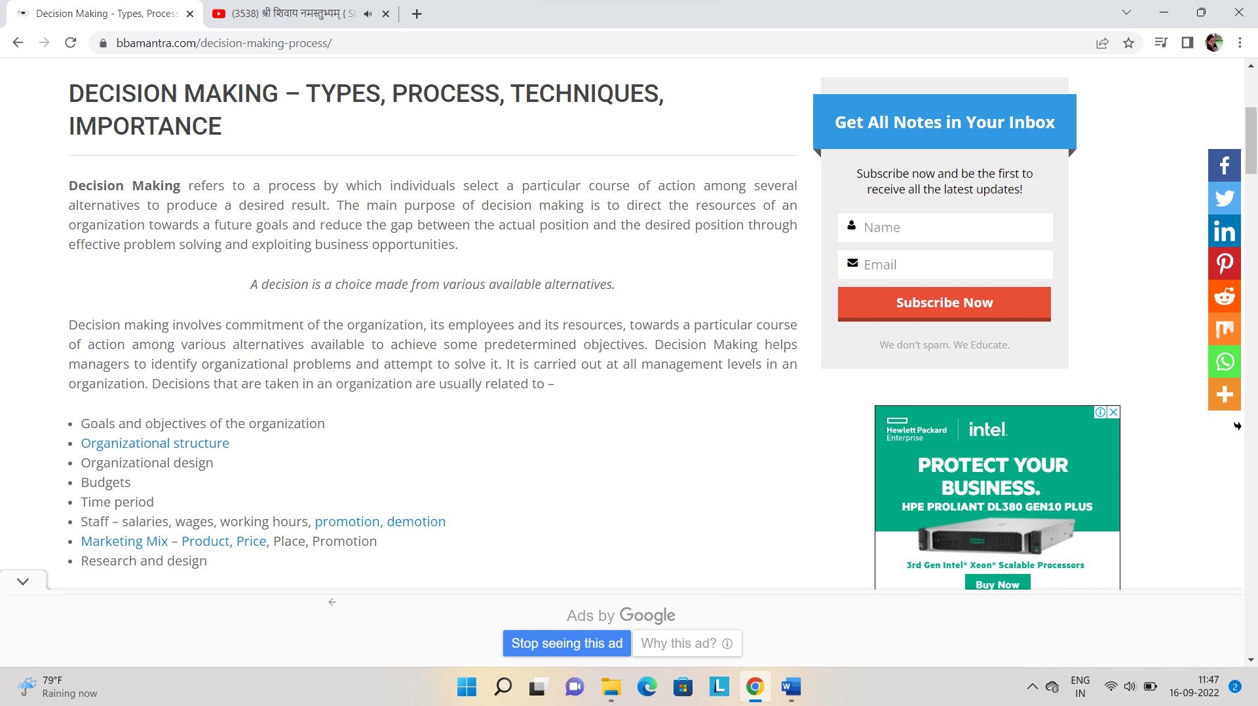

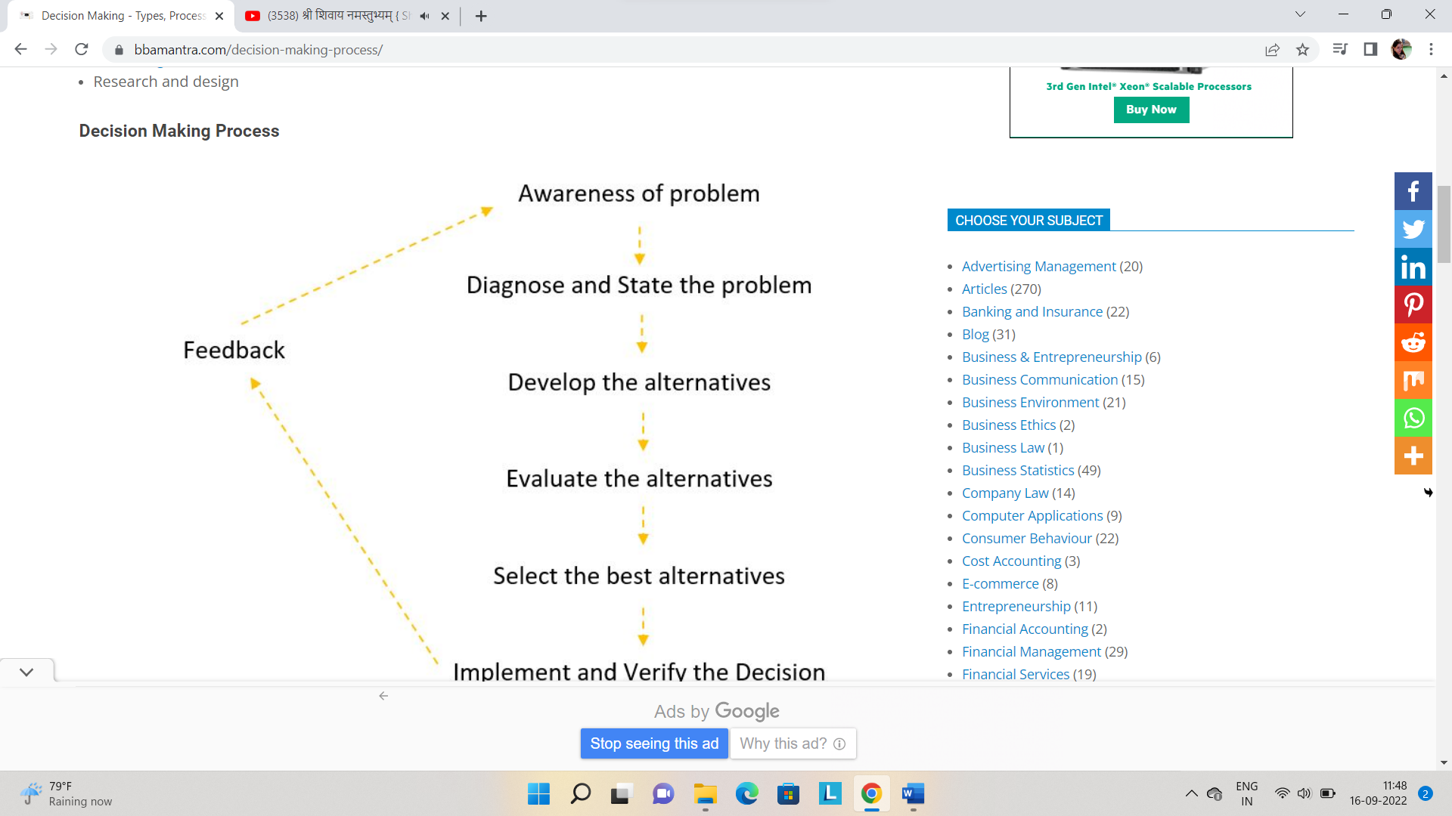

Decision Making Process

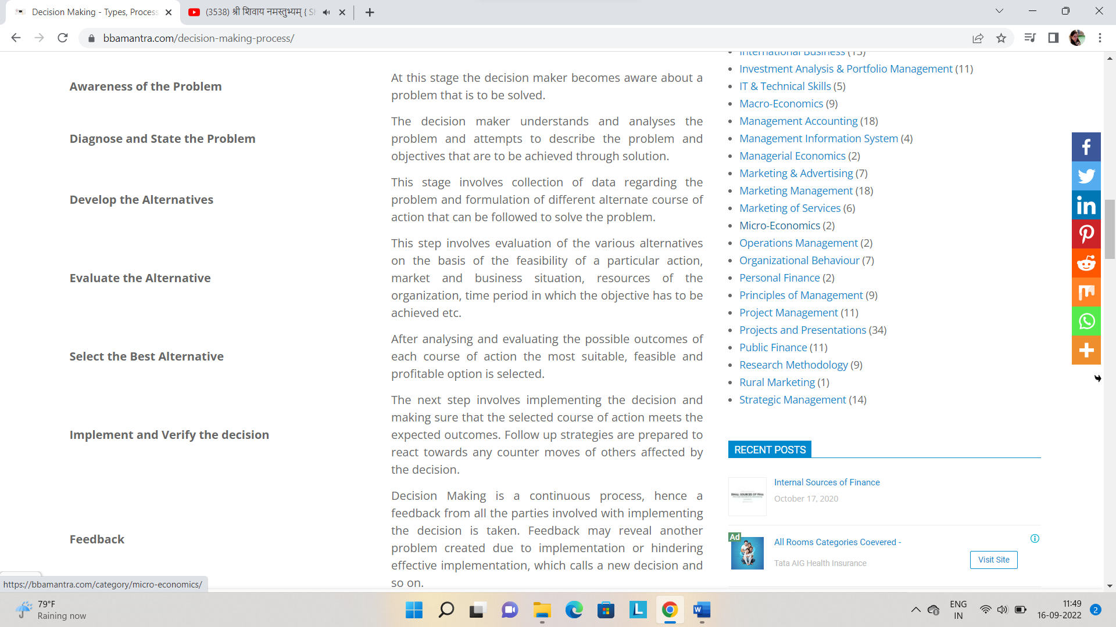

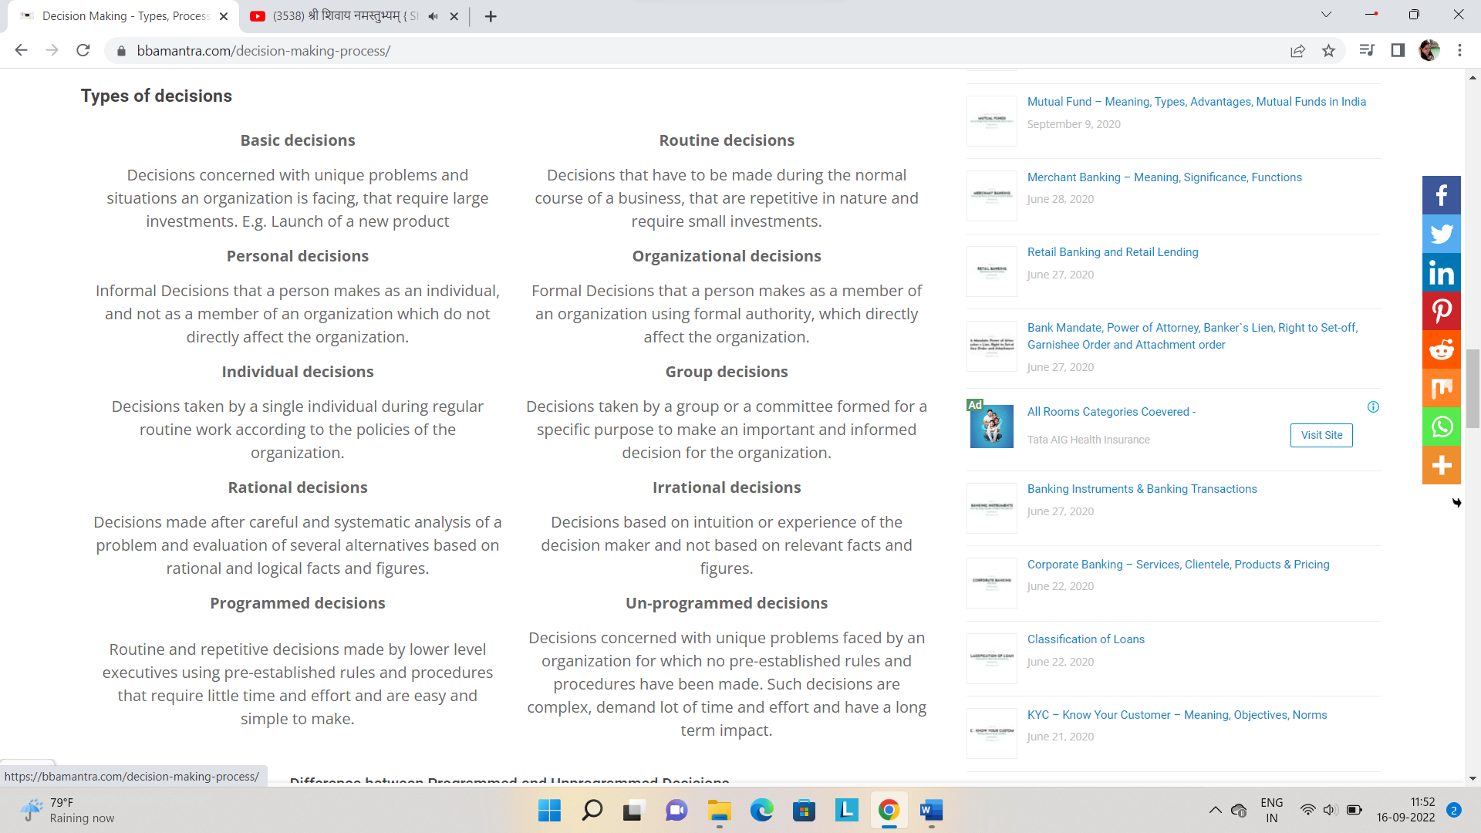

**Decision-making under Certainty:**

A condition of certainty exists when the decision-maker knows with reasonable certainty what the alternatives are, what conditions are associated with each alternative, and the outcome of each alternative. Under conditions of certainty, accurate, measurable, and reliable information on which to base decisions is available.

The cause and effect relationships are known and the future is highly predictable under conditions of certainty. Such conditions exist in case of routine and repetitive decisions concerning the day-to-day operations of the business.

**Decision-making under Risk:**

When a manager lacks perfect information or whenever an information asymmetry exists, risk arises. Under a state of risk, the decision maker has incomplete information about available alternatives but has a good idea of the probability of outcomes for each alternative.

While making decisions under a state of risk, managers must determine the probability associated with each alternative on the basis of the available information and his experience.

**Decision-making under Uncertainty:**

Most significant decisions made in today’s complex environment are formulated under a state of uncertainty. Conditions of uncertainty exist when the future environment is unpredictable and everything is in a state of flux. The decision-maker is not aware of all available alternatives, the risks associated with each, and the consequences of each alternative or their probabilities.

The manager does not possess complete information about the alternatives and whatever information is available, may not be completely reliable. In the face of such uncertainty, managers need to make certain assumptions about the situation in order to provide a reasonable framework for decision-making. They have to depend upon their judgment and experience for making decisions.

There are several modern techniques to improve the quality of decision-making under conditions of uncertainty.

**The most important among these are:**

(1) Risk analysis, Managers who follow this approach analyze the size and nature of the risk involved in choosing a particular course of action.

For instance, while launching a new product, a manager has to carefully analyze each of the following variables the cost of launching the product, its production cost, the capital investment required, the price that can be set for the product, the potential market size and what percent of the total market it will represent.

(2) Decision trees

By means of a **“tree”** diagram depicting the decision points, chance events and probabilities involved in various courses of action, this technique of decision-making allows the decision-maker to trace the optimum path or course of action.

Cultural issues in management

1. **Different Communication Styles**

The way people communicate varies widely between, and even within, cultures. One aspect of communication style is language usage. Across cultures, some words and phrases are used in different ways. For example, even in countries that share the English language, the meaning of "yes" varies from "maybe, I'll consider it" to "definitely so," with many shades in between.

Another major aspect of communication style is the degree of importance given to non-verbal communication. Non-verbal communication includes not only facial expressions and gestures; it also involves seating arrangements, personal distance, and sense of time. In addition, different norms regarding the appropriate degree of assertiveness in communicating can add to cultural misunderstandings. For instance, some white Americans typically consider raised voices to be a sign that a fight has begun, while some black, Jewish and Italian Americans often feel that an increase in volume is a sign of an exciting conversation among friends. Thus, some white Americans may react with greater alarm to a loud discussion than would members of some American ethnic or non-white racial groups.

1. **Different Attitudes Toward Conflict**

Some cultures view conflict as a positive thing, while others view it as something to be avoided. In the U.S., conflict is not usually desirable; but people often are encouraged to deal directly with conflicts that do arise. In fact, face-to-face meetings customarily are recommended as the way to work through whatever problems exist. In contrast, in many Eastern countries, open conflict is experienced as embarrassing or demeaning; as a rule, differences are best worked out quietly. A written exchange might be the favored means to address the conflict.

1. **Different Approaches to Completing Tasks**

From culture to culture, there are different ways that people move toward completing tasks. Some reasons include different access to resources, different judgments of the rewards associated with task completion, different notions of time, and varied ideas about how relationship-building and task-oriented work should go together.

When it comes to working together effectively on a task, cultures differ with respect to the importance placed on establishing relationships early on in the collaboration. A case in point, Asian and Hispanic cultures tend to attach more value to developing relationships at the beginning of a shared project and more emphasis on task completion toward the end as compared with European-Americans. European-Americans tend to focus immediately on the task at hand, and let relationships develop as they work on the task. This does not mean that people from any one of these cultural backgrounds are more or less committed to accomplishing the task, or value relationships more or less; it means they may pursue them differently.

1. **Different Decision-Making Styles**

The roles individuals play in decision-making vary widely from culture to culture. For example, in the U.S., decisions are frequently delegated -- that is, an official assigns responsibility for a particular matter to a subordinate. In many Southern European and Latin American countries, there is a strong value placed on holding decision-making responsibilities oneself. When decisions are made by groups of people, majority rule is a common approach in the U.S.; in Japan consensus is the preferred mode. Be aware that individuals' expectations about their own roles in shaping a decision may be influenced by their cultural frame of reference.

1. **Different Attitudes Toward Disclosure**

In some cultures, it is not appropriate to be frank about emotions, about the reasons behind a conflict or a misunderstanding, or about personal information. Keep this in mind when you are in a dialogue or when you are working with others. When you are dealing with a conflict, be mindful that people may differ in what they feel comfortable revealing. Questions that may seem natural to you -- What was the conflict about? What was your role in the conflict? What was the sequence of events? -- may seem intrusive to others. The variation among cultures in attitudes toward disclosure is also something to consider before you conclude that you have an accurate reading of the views, experiences, and goals of the people with whom you are working.

1. **Different Approaches to Knowing**

Notable differences occur among cultural groups when it comes to epistemologies -- that is, the ways people come to know things. European cultures tend to consider information acquired through cognitive means, such as counting and measuring, more valid than other ways of coming to know things. Compare that to African cultures' preference for affective ways of knowing, including symbolic imagery and rhythm. Asian cultures' epistemologies tend to emphasize the validity of knowledge gained through striving toward transcendence.

Recent popular works demonstrate that our own society is paying more attention to previously overlooked ways of knowing. Indeed, these different approaches to knowing could affect ways of analyzing a community problem or finding ways to resolve it. Some members of your group may want to do library research to understand a shared problem better and identify possible solutions. Others may prefer to visit places and people who have experienced challenges like the ones you are facing, and get a feeling for what has worked elsewhere.